Causeway Coast and Glens Borough Council

Citizen's Newsletter
  - 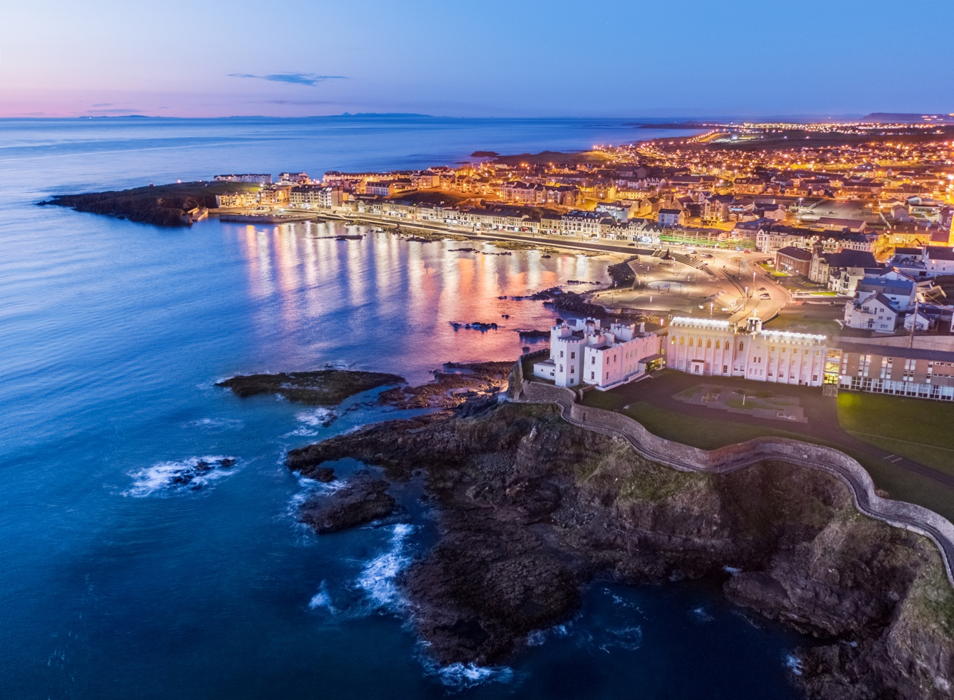

  - Portstewart. Image courtesy of Patriyk Sadowski.

Inside this issue

Fitness suites transformed
Pages 6-7



Contact us
Sheskburn House, Ballycastle: 028 2076 2225
Riada House, Ballymoney: 028 2766 0200
Cloonavin, Coleraine: 028 7034 7034
Connell Street, Limavady: 028 7772 2226
Planning (located in Cloonavin): 028 7034 7100

Useful Numbers
Housing Executive Main number
(including grass cutting and graffiti): 03448 920 900
Repairs line: 03448 920 901
Housing benefit: 03448 920 902
Land Registry: 0300 200 7803
Rates (Property Rating and Valuation): 0300 200 7801
DfI Roads Northern Division: 0300 200 7891
Flooding incident line: 0300 2000 100
Flooding emergency: 999
Street lighting faults (emergency): 0300 200 7899
Telephone / Utility Boxes (BT fault): 0800 023 2023
Burst water mains and blocked sewers: 03457 440088 (24 hours)
Water pollution hotline: 0800 80 70 60

If an emergency affects your supply of electricity, gas or water, use the contact details below:
Northern Ireland Electricity: 0345 7643 643
Northern Ireland Water: 0345 7440 088
Phoenix Natural Gas: 0800 002 001
Firmus Energy: 0800 002 001

Get in touch
The Citizens’ Newsletter can be obtained in alternative formats including large print, braille and on audio cassette.
Please email all requests and feedback to Email Causeway Coast and Glens Citizen Newsletter

A message from the Mayor
Welcome to the 2024 edition of Citizens’ Newsletter, our annual magazine which offers a glimpse into some of the fantastic work being undertaken by Council.

As you will see, we have a bumper events calendar to look forward to for the year ahead, including the highly anticipated return of the NI International Air Show to Portrush, following a five-year absence.

Work has been completed on upgrading fitness suites at our leisure centres across the Borough following a £600,000 investment, providing modern facilities to help encourage an active lifestyle.

Council continues to champion sustainability in all its forms through our LiveSmart campaign; a great example of this is the ‘2GoCup’ scheme, a pioneering new initiative that aims to eliminate single use plastic cups and help keep our Borough beautiful.

I know that for many of you, the rising cost of living continues to present challenges that can sometimes feel overwhelming. Please don’t be afraid to ask for help; whether it be issues such as financial difficulties, loneliness or anything else, I would encourage you to seek support from the very approachable organisations we have here in the Borough, such as The Salvation Army, St Vincent de Paul Society or local church and community groups.

As Mayor, I take immense pride in representing the people of Causeway Coast and Glens and I will continue to do my utmost to advocate for this fantastic area on your behalf.

Councillor Steven Callaghan QPM
The Mayor of Causeway Coast and Glens Borough Council

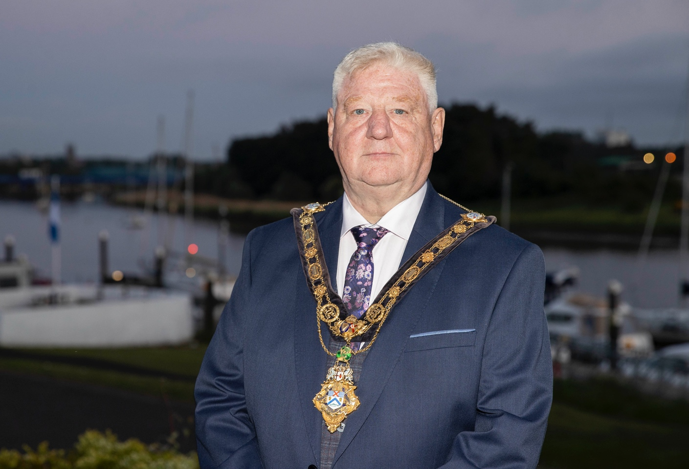
The Mayor of Causeway Coast and Glens Borough Council, Councillor Steven Callaghan QPM.

Courtyard Café goes ‘CupSmart’
Café on ambitious mission to eliminate single use cups
Disposable drinks cups often end up as litter across our Borough, impacting our towns and villages, countryside and marine environment. It is estimated that we use over 70 million single use drinks cups each year in Northern Ireland, with only 11% of these taken home to be disposed of. Couple this with the astonishing statistic that up to 70% of people here have a reusable cup but only 15% use it regularly, you can see we have a problem.

What’s the solution? The Courtyard Café in Ballycastle, part of the Ballycastle Community Hub charity, has embarked on an ambitious mission to eliminate single use cups, saving money in the process and playing its role in reducing litter in one of the many beautiful parts of our Borough.

The introduction of the ‘2GoCup’ scheme in conjunction with Council is a strong and positive statement. Its impact is only eclipsed by its simplicity – you order a hot drink in the Courtyard Cafe, pay a £2 deposit for your reusable cup and enjoy your drink. If you bring the cup back, you can reuse it or ask for your deposit back. If you don’t bring it back, the café retains your £2 deposit which coincidentally is the cost
of a new cup.

CupSmart, part of the LiveSmart campaign offered by Council, promotes not just having a reusable cup but using it regularly. LiveSmart contains many campaigns for practical engagement in a range of environmental issues.

For more information on CupSmart or other LiveSmart campaigns, please check out Causeway Coast and Glens Live smart Website or Email Causeway Coast and Glens Recycling
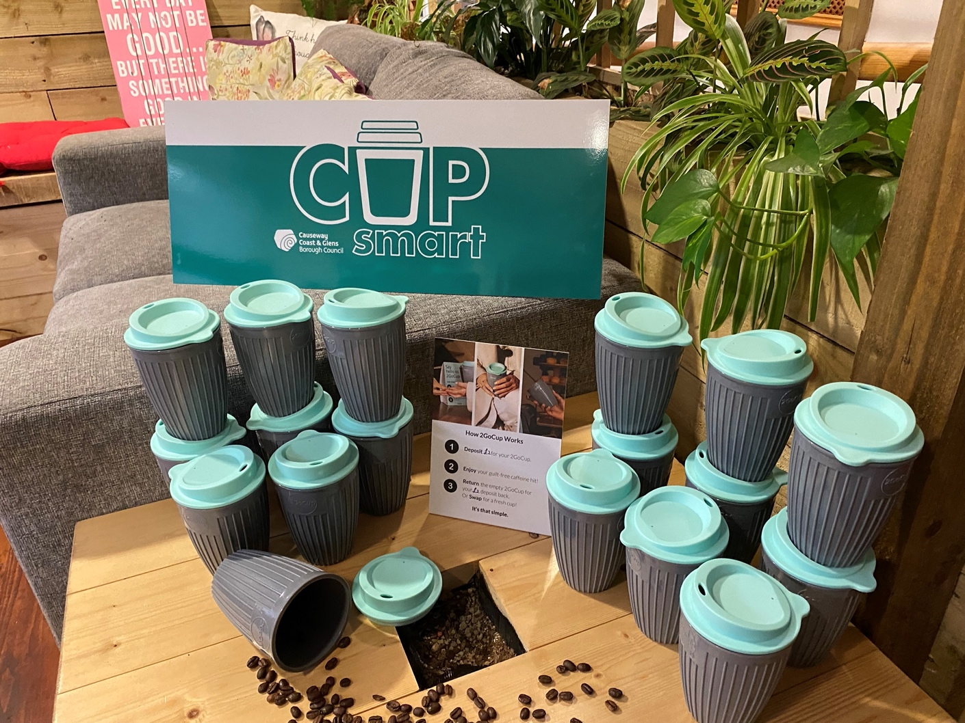
The ‘2GoCup’ range at The Courtyard Cáfe in Ballycastle.

Recycling locator
Let’s get it right

We all get recycling. Now let’s get it right. There’s more to do so let’s make it part of our everyday life. Today, the work is about recycling more of the right things, more often.

Check out how and where to recycle an item correctly by using the recycling locator. Simply enter your postcode into Recycle Now Website to get advice on recycling at home.

Make the most of your food waste recycling service

Most of us agree that food is increasingly expensive and reducing food waste is important, yet food waste still makes up a third of our black bin rubbish.

Food waste is the single most significant recyclable material in the black bin. Make your caddy and brown bin the only place for food waste.

The best thing we can do with our food is enjoy it, but for food that can’t be eaten or used, make your caddy the go-to bin. From coffee grounds
and fruit skins to bones and eggshells, there is no amount too small. Emptying your kitchen caddy regularly and using a liner will keep it fresh.

Our brown bin waste is made into garden compost in Northern Ireland, creating local jobs and new product.

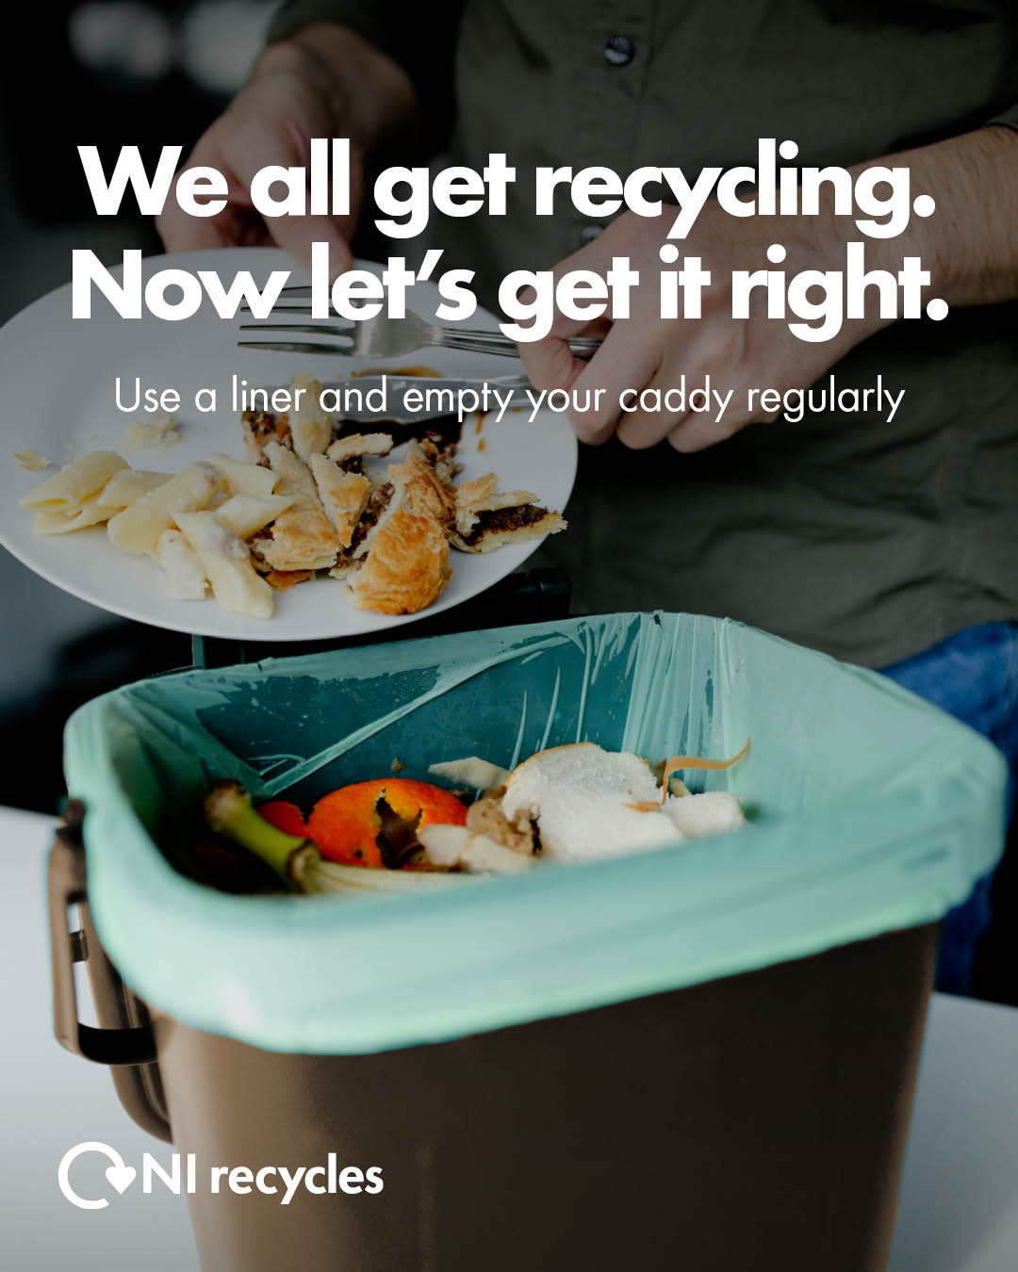
Poster artwork for NI recycles campaign

Explore the place you call home

With Easter around the corner and the weather getting better, the Causeway Coast and Glens tourism team encourage everyone to be a ‘Tourist at Home’ this year.

When was the last time you enjoyed one of our many unique experiences, our local food and drink, our exciting events and our breath-taking scenery? Often the only time we enjoy these experiences is when we have our own visitors.

Tourism in Causeway Coast and Glens is worth over £192million, it attracts and creates jobs, sustains communities and enriches our lives.
There is no better way to understand the value of the industry and its appeal than to discover what’s on your doorstep.

This Spring why not:
- Take your camera for a walk
- Get up for sunrise
- Visit a viewpoint
- Walk a route you normally drive
- Take a guided tour with one of our many
- qualified guides
- Eat at a local award-winning restaurant
- Book a staycation

For advice on what to see and do in the Causeway Coast and Glens visit one of our Visitor Information Centres or Visit Causeway Coast and Glens Website

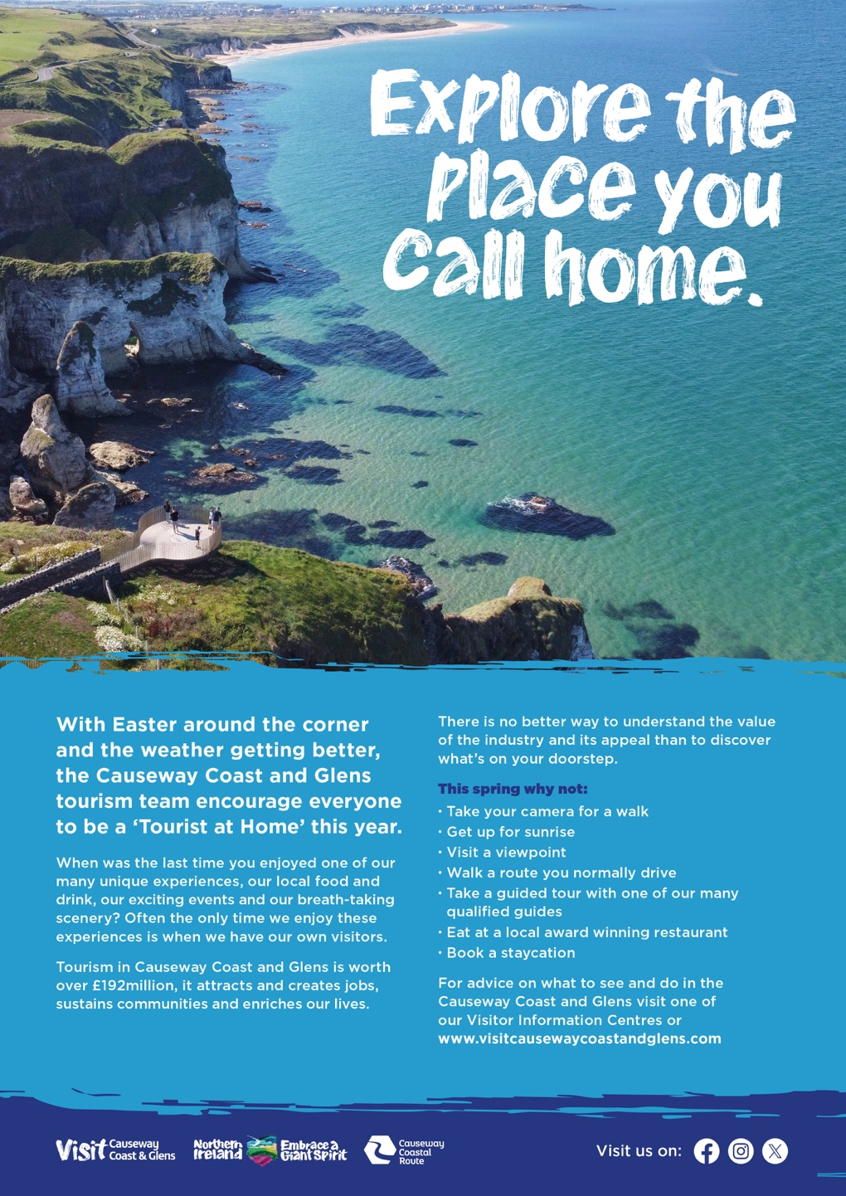
Poster artwork for ‘Explore the Place you Call Home’.

A guide to what’s on throughout 2024

Event calendar 2024

Friday 19 & Saturday 20 April
Ballymoney Spring Fair

Monday 6 – Saturday 11 May
NW200 Race Week Festival

May
Rathlin Sound Festival

July & August
Seasonal Summer Programme (Summer Theatre Programme)

Saturday 27 July
Summer Fireworks Evening Portstewart (Finale of Red Sails)

Saturday 10 August
Summer Entertainment & Fireworks Evening Portrush

Saturday 24 - Tuesday 27 August
Ould Lammas Fair

Saturday 7 & Sunday 8 September
NI International Air Show

Friday 4 - Sunday 6 October
Bushmills Salmon and Whiskey Festival

October
Halloween celebrations will take place across the Borough in Ballycastle, Ballymoney, Coleraine and Limavady with fireworks, live music and entertainment, fire-poi, spooky parades and workshops.

Thursday 14 - Sunday 17 November
Atlantic Sessions

December
Christmas light switch-ons will take place across the region with music, entertainment, animation, parades and lots of fun to help get you in the festive spirit.

Check social media Cause Coast and Glens Facebook Page for details.
For other events and experiences across the destination Visit Causeway Coast and Glens – Whats On Webpage

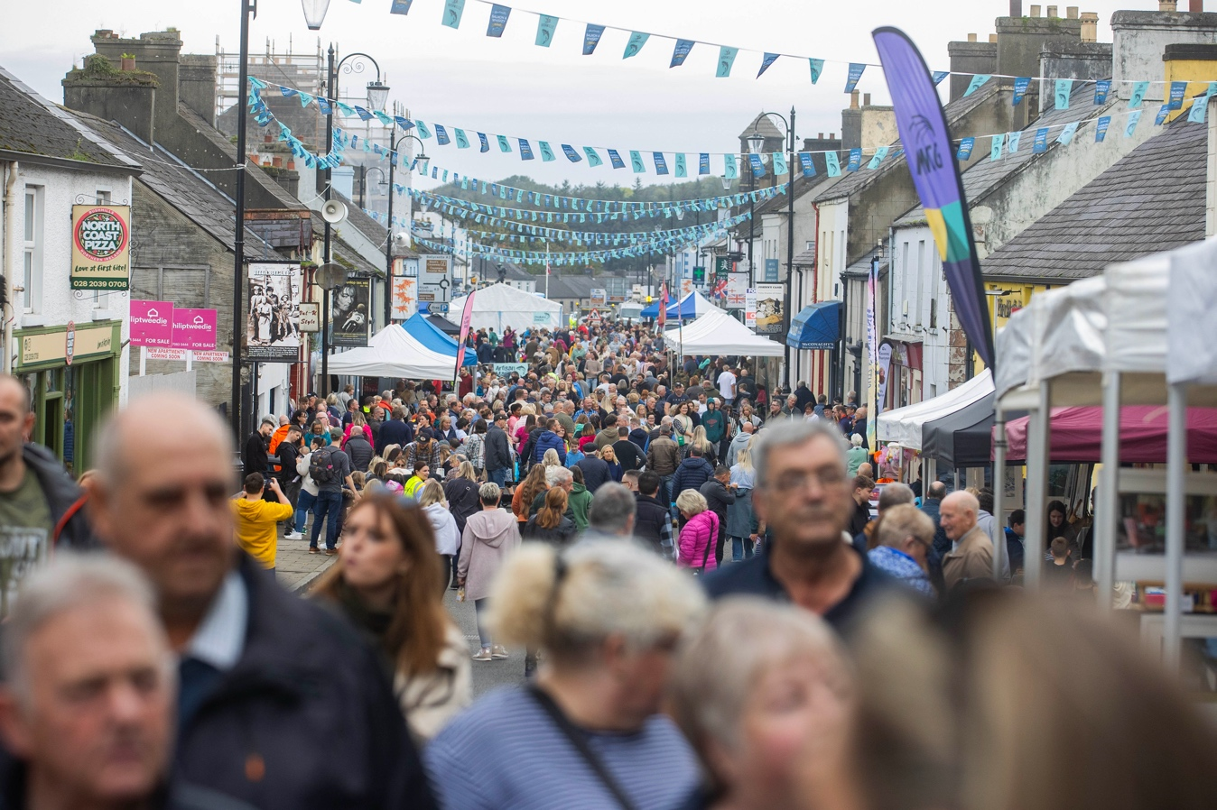
Salmon and Whiskey Festival.

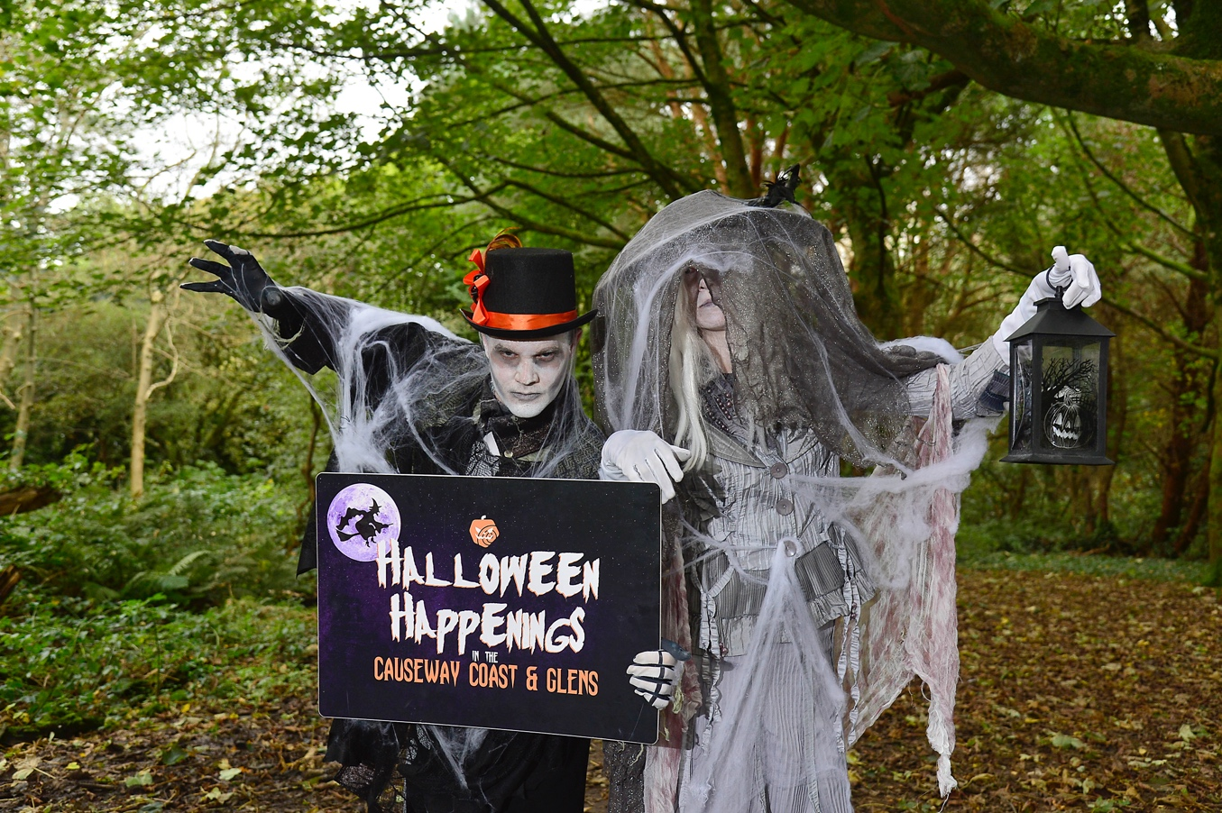
Halloween Happenings.


Causeway Coast and Glens Air Show.

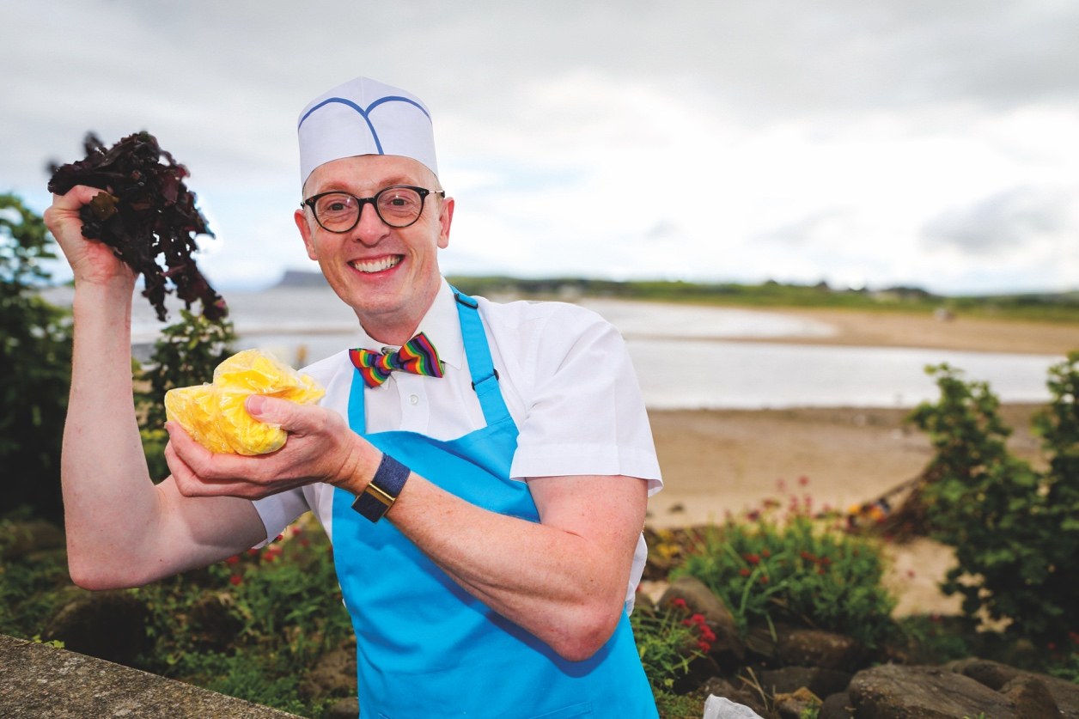
Yellow Man at the ‘Ould Lammas Fair’.

Fitness suites transformed following £600k investment

Citizens and visitors to the Borough who have recently attended one of Council’s Leisure Centre Fitness Suites will have experienced a complete transformation in the offering available.

Following an investment of £600,000 by Council, fitness suite upgrade projects were undertaken at Coleraine Leisure Centre, Roe Valley Leisure Centre, Joey Dunlop Leisure Centre and Sheskburn Recreation Centre.

The upgrade projects feature a full range of Pulse Fitness, state of the art equipment, including free weights, strength and conditioning and functional training kit. The change of décor within the facilities also provides a welcome, modern, motivating environment for individuals to achieve their goals.

Welcoming the upgrades, the Mayor of Causeway Coast and Glens, Councillor Steven Callaghan said: “We know that living an active lifestyle is very important for overall wellbeing, and Council is committed to helping our residents achieve this through the facilities and services that we provide.

“The upgraded spaces and equipment coupled with our knowledgeable staff, who are here to assist and guide users, is a great asset to the Borough and places Causeway Coast and Glens Borough Council at the forefront of fitness provision in the area.”

Citizens can use any of the facilities on a pay-as-you-go basis or by availing of one of our membership options like Active Plus or Thrive Household.

For more details Email Causeway Coast and Glens Leisure Membership or Visit Causeway Coast and Glens Leisure Centre Promotions Webpage

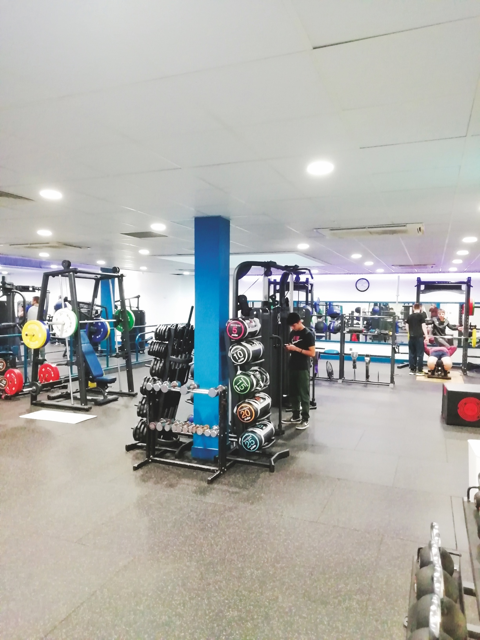
Coleraine Leisure Centre.

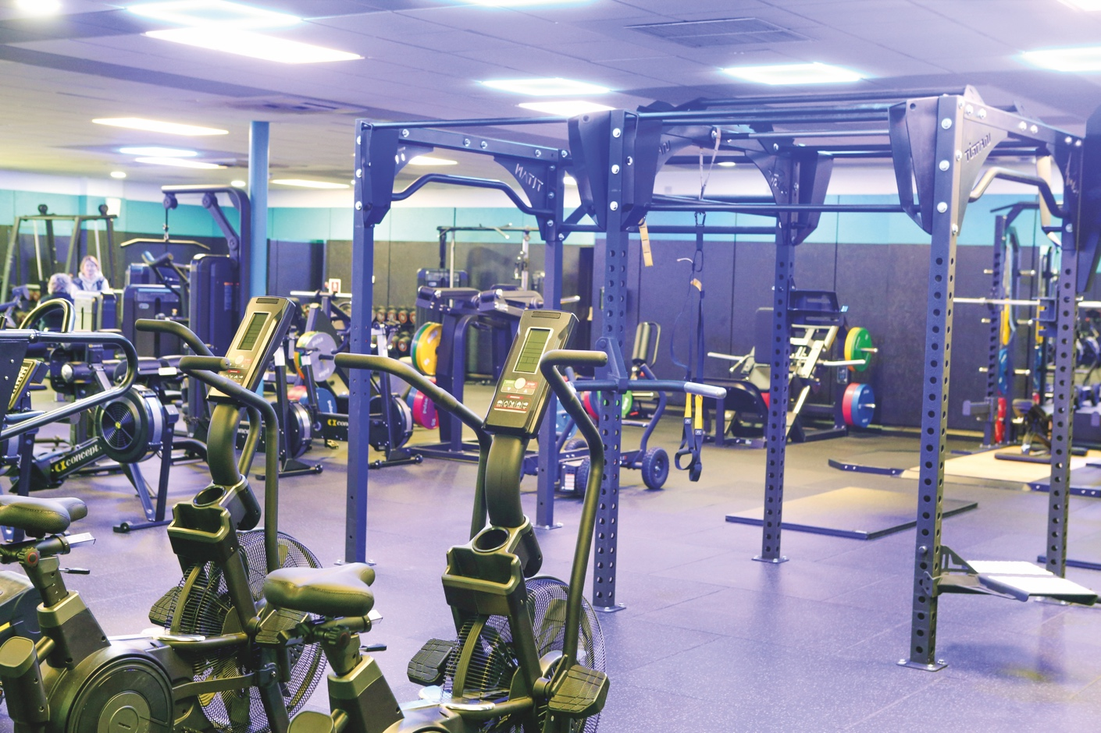
Joey Dunlop Leisure Centre.

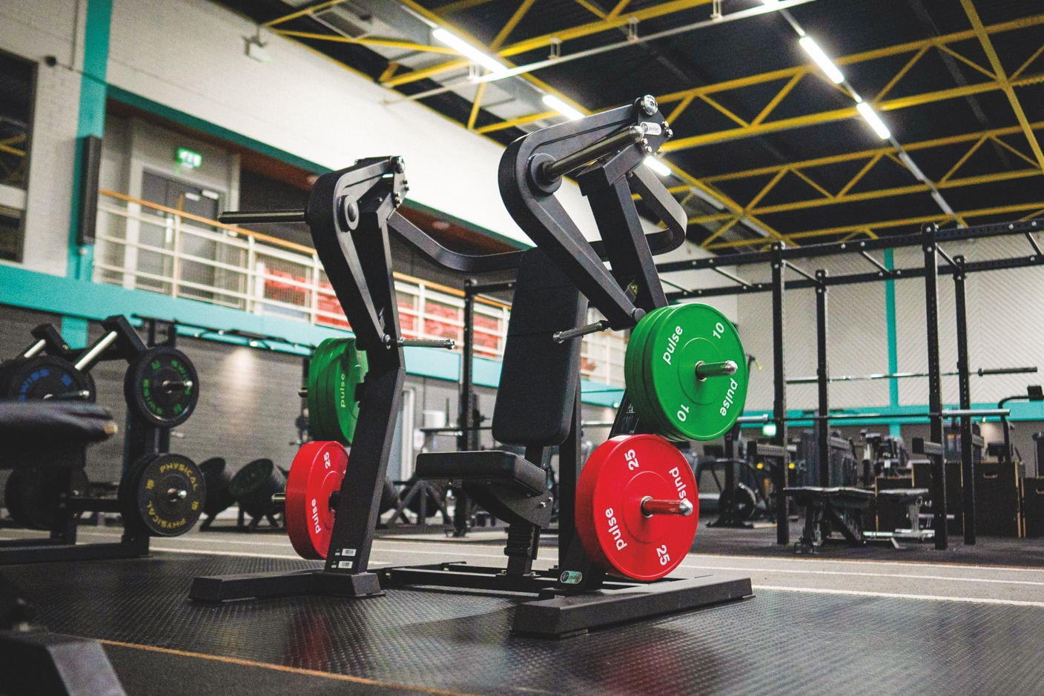
Roe Valley Leisure Centre

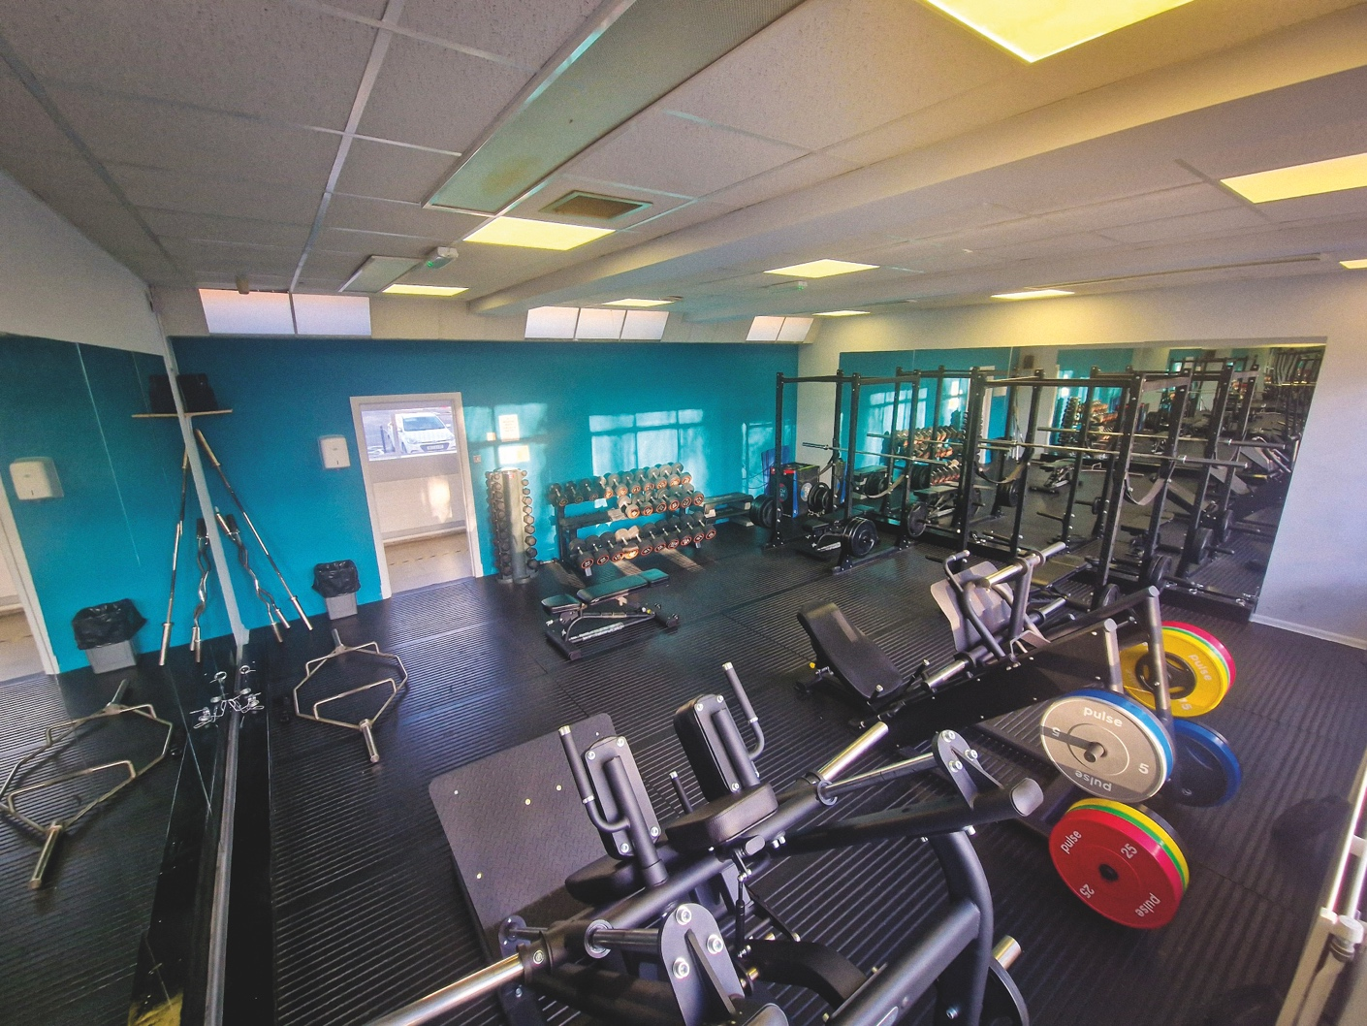
Sheskburn Recreational Centre

Active Life scheme encourages older adults to be more involved in sport and physical activity

Movement makes people happier and healthier, and it does the same thing for our communities – with life-changing benefits that have huge social value. Active Life is Council’s plan to make being physically active a normal part of life for everyone in the Borough, through indoor racquet sports and exercise sessions at five of our leisure/sports centres.

Active Life sessions - exercise designed to improve health, flexibility, balance and strength in a fun environment:

Mondays - Sheskburn Recreation Centre, Ballycastle Tuesdays - Roe Valley Leisure Centre, Limavady
Thursdays - Joey Dunlop Leisure Centre, Ballymoney & Coleraine Lesiure Centre
Fridays - Dungiven Sports Centre

Racquet sports - fun social sessions to encourage participation:

Mondays - Sheskburn Recreation Centre, Ballycastle Tuesdays - Roe Valley Leisure Centre, Limavady
Thursdays - Joey Dunlop Leisure Centre, Ballymoney
Thursdays - Coleraine Leisure Centre

Apply now for Sports Grant and Bursary Programme

Causeway Coast and Glens Sports Grant and Bursary Programme is now open to all applicants.

Funding is available to local individuals, sports clubs and National Governing Bodies (NGB’s) representing a sport recognised by Sport NI.

The programme is about developing positive relationships between sporting organisations and individuals representing their clubs in a sport recognised by Sport NI.

Council will consider up to 100% funding of total eligible costs up to a maximum of £400 for eligible applications.

If required, you can discuss your application with one of Council’s Sports Development Managers before submitting your application by contacting Email Sports Development at Causeway Coast and Glens

For detailed guidance notes and application form, please visit Causeway Coast and Glens Sports Grant Programme Website

Growth Deal is moving forward

Over the next few years, it is envisaged that Northern Ireland will benefit from a package of investment from four City and Growth Deals. The combined funding from the Northern Ireland Executive and UK Government will total £1.3bn, which will be complemented by the private sector and other sources of funding.

One of the four deals is the Causeway Coast and Glens Growth Deal. Our Growth Deal is anticipated to see Causeway Coast and Glens receive £72m capital funding after the NI Executive agreed to match fund the UK Government’s Growth Deal allocation.

The following objectives have been established for the Growth Deal:

1. Attract, support and grow more business, with a focus on export;
2. Position Causeway Coast and Glens as the ‘go-to’ region for both business and pleasure;
3. Regenerate some of the areas smaller settlements into thriving and sustainable rural economies;
4. Improve key elements of the tourism transport network and tourism destinations;
5. Work with education and employers to raise aspirations and improve employability and skills.

The deal has identified three key themes/sectors to help grow the local economy and up to nine prospective projects, as follows:

• Tourism and regeneration
• Infrastructure
• Digital & Innovation

Further details on the projects will be published when Heads of Terms have been agreed with Government in Spring 2024.

Say hello to Go Succeed

Are you ready to take the next step in business?

Go Succeed is the new go-to source for expert business advice led by Northern Ireland’s 11 local councils. Whether you’re a budding entrepreneur just starting out; are looking to grow your business; or are planning to scale up; our team of industry experts will provide tailored support and guidance to help you achieve your business goals.

Search Go Succeed NI, scan the QR code in artwork or call 0800 027 0639 for more information.

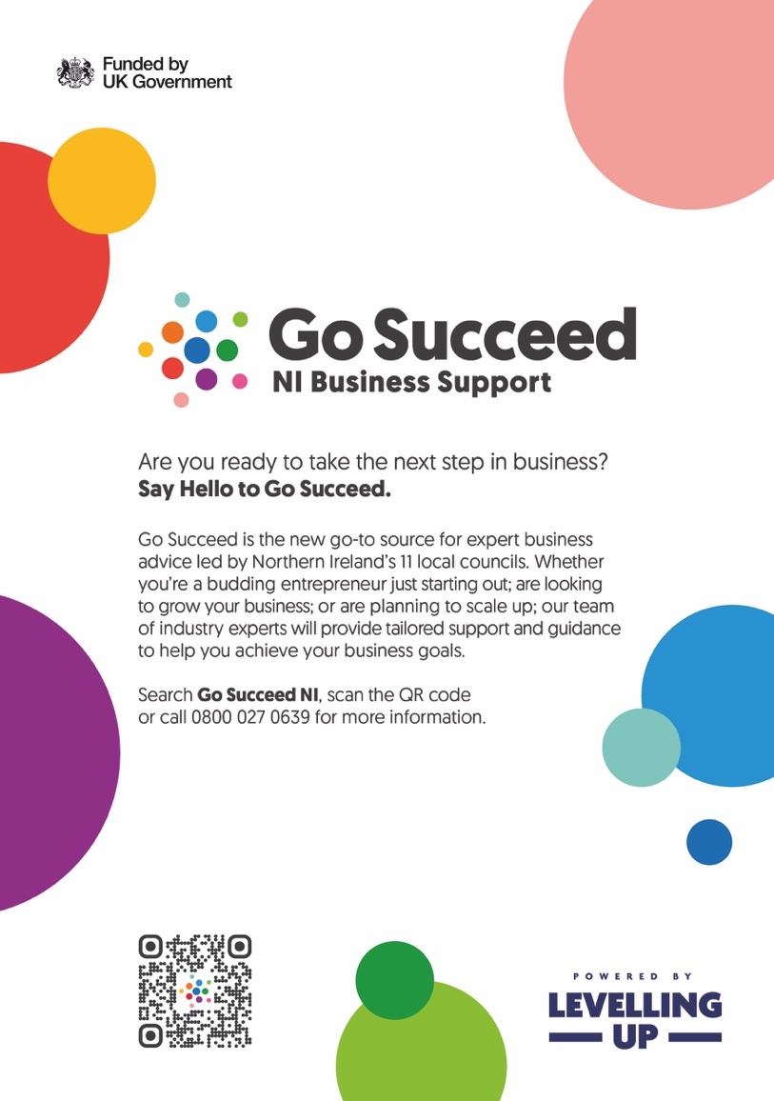
Go Succeed Poster Artwork

Our commitment to improving accessibility

As a Council, we strive to improve accessibility for all our citizens and visitors.

We will:

- Listen to you.
- Review emerging issues and put necessary actions in place.
- Include an equality/inclusion action per year in all service areas.
- Review and identify borough-wide options for teenager activity.
- Continue to run events in smaller areas within our borough.
- Extend our accessible communication provision for example Easy Read, Makaton use, premises mapping, accessible site videos etc.
- Retrain staff on ‘Just a Minute’ (JAM) awareness.
- Achieve Autism Impact awards at our 3 main Leisure Centres and continue our work towards becoming an Autism Friendly borough.
- Review the condition of all our assets using the Equality Commissions Every Customer Counts Audit process to identify and schedule improvements.
- Review public toilet provision.
- Continue to deliver inclusive cultural arts programmes in our facilities.
- We need your help and support to become as inclusive as possible!
- You can do this by:
- Becoming a consultee who we contact with surveys;
- Joining our equality forum which meets once per quarter;
- Emailing us with suggestions for improvement;
- Telling us your needs or about issues you found when using our facilities.
Email Equality at Causeway Coast and Glens for further information.

‘World of Stories’ project explores history of migration to our Borough

During 2023, Council’s Good Relations and Museums teams combined their efforts to produce an exhibition entitled ‘World of Stories’, which explored the 20th and 21st century experiences of those who resettled here from around the world. The project explored both historical records and personal experiences, some joyous and some heartbreaking.

All parts of the World of Stories project can be viewed at NI Archive – A World of Stories Website

People migrate to other countries for various reasons, and many of us have stories about where our own family hailed from originally. Some will move to escape danger, for love, or to seek a better life. Many of those who come here contribute positively to the workforce, for example when we have a shortage of doctors.

For those fleeing danger, the terminology can be confusing: an Asylum Seeker is someone who has fled their home country due to persecution, war or violence and is seeking protection elsewhere, a human right enshrined in international law. Usually, they will have experienced significant trauma on their way to a safer place, then go through a lengthy process to establish if they are allowed to remain. Throughout this time, they cannot work or receive state benefits, but are placed into basic accommodation and given between £9 and £45 per week, all funded by the Home Office. A Refugee is someone who has been granted the right to remain and can work.

Our Borough has a rich and diverse community and Council, like all public bodies, has a statutory duty to promote Good Relations between all of its residents.
To find out more about some of the work carried out through council’s Good Relations team, please visit Causeway Coast and Glens – Good Relations Website

Cyber Safety resource launched to help protect young people online

Causeway Coast and Glens PCSP has launched a ‘cyber safety’ resource - the only one of its kind in Northern Ireland.

The PCSP partnered with the NSPCC, the Northern and Western Health Trusts and the Education Authority to develop the toolkit, which aims to support young people with topics such as:

- suicide, mental health, and self-esteem
- online bullying
- gaming and gambling
- sharing and receiving inappropriate images

The resource is intended to be used by a range of organisations, such as in schools or youth groups. It provides animations, lesson plans and other supporting resources designed to support young people in need.

The free resource can be viewed at Online Safety and Mental Health Booklet

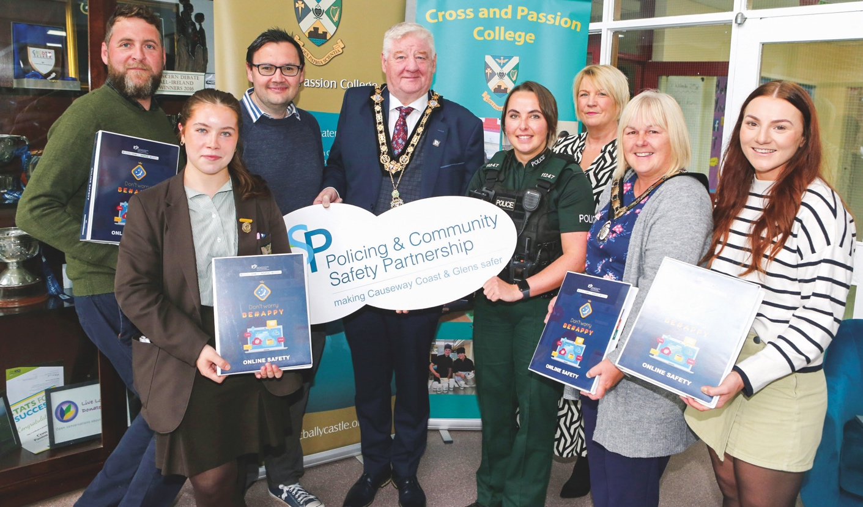
Policing and Community Safety Partnership launch

Where to turn

Cost of living support with food, energy and financial advice

Are you concerned about the cost of living?
Causeway Coast and Glens Borough Council and partners are working to support and offer guidance to our residents during the cost-of-living crisis. We want to ensure that residents know where to turn for advice and practical support.

Advice about benefits, money, debt, housing and other issues
Council supported advice services provide free, independent and confidential advice and support on a range of concerns including benefits, money and debt, employment, housing, consumer issues.

Community Advice Causeway
Telephone Helpline: 028 7034 4817
Email Community Advice Causeway
Face to face appointments can be arranged in Ballycastle, Ballymoney, Coleraine and Limavady. Evening and weekend appointments are available. Specialist debt advice available.

Glenshane House
A generalist advice service provided by Glenshane Community Development for the Dungiven area.
Tel: 028 7774 2494

Support with food and essential items
If you are struggling to put food on the table, foodbanks can provide you with enough food for balanced and nutritional meals for 3 days. They can also provide toiletries, baby products, cleaning products and pet food, where available.

Ballycastle Foodbank
Telephone: 07536986448 or 028 20054006
Email Ballycastle Foodbank
Address: Unit 6 Causeway Enterprise Centre Leyland Rd BT54 6EZ

Ballymoney Foodbank
Telephone: 07565840571
Email Ballymoney Foodbank
Address: Unit 10 41 Ballymena Rd BT53 7EX

Causeway Foodbank
Telephone: 028 7022 0005
Email Casueway Foodbank
Address: The Hope Centre, 10 Hillmans Way, Coleraine BT52 2ED

Outreach foodbanks are also available at limited times at Terrace Row Presbyterian Church, Coleraine Elim & Hazelbank Presbyterian Church, Portstewart Baptist Church as well as their Mobile Open Door service.

Roe Valley Foodbank
Telephone: 028 777 65438
Email Row Valley Foodbank
Address: LCDI, Old Hospital site, 24 Benevenagh Drive, Limavady BT49 0AQ

Other community food projects
Many local community organisations provide food support for people living in the area or for their service users. Further contact details and drop-in times are listed on Council’s website – Causeway Coast and Glens – Community Fridges Website

Social Supermarkets
Social Supermarkets provide members with the opportunity to shop at a reduced cost for a period of months alongside engaging in a range of other wraparound supports.

RESET Social Supermarket
Located at Vineyard Compassion, The Hope Centre, 10 Hillmans Way, Coleraine BT52 2ED
Telephone: 028 7022 0005
Email RESET Social Supermarket

LCDI Social Supermarket
Located at Roe Valley Community Foodbank in LCDI, 24 Benevenagh Drive, Limavady BT49 0AQ
Telephone: 02877765438
Email LCDI Social Supermarket

Support with energy costs
St Vincent DePaul
SVP can offer a wide range of supports, all in the strictest of confidence and based on the need of the individual or family. They may be able to offer some practical or financial assistance towards day to day essentials, including fuel.

Ballycastle (St Brigid’s): 07754722022
Ballymoney (St Patrick’s): 07860455549
Cloughmills & Dunloy (Sacred Heart): 07513 095505
Coleraine (St John’s - West of the Bann): 07752017340
Coleraine (St Malachy’s - East of the Bann): 07738837959
Cushendall & Glenariff (St Mary’s): 07548780121
Dungiven (St Patrick’s): 07927929923
Garvagh (Errigal): 07563595868
Greysteel, Faughanvale (St Anne’s): 07538683580
Kilrea (St Anne’s): 07597955305
Limavady (St Canice’s): 07512360388
Feeny (St Joseph’s Banagher): 07593954973
Portrush (St Patrick’s): 07508549574
Portstewart (St Mary’s): 07508549572
Rasharkin (St Mary & St Columba’s): 07547135740

Salvation Army
The Salvation Army offers friendship and practical help and support and may be able to offer emergency help with fuel.

Ballymoney and wider Causeway area:
Meetinghouse Street, BT53 6JN
Telephone: 028 2766 5520
Email Ballymoney Salvation Army
Limavady: 72-76 Main Street, BT49 9HS
Telephone: 028 777 22613

Fuel Stamp Savings Scheme
A Fuel Stamp Savings Scheme is available to help householders budget towards the cost of heating your home. The stamps, which cost £5, are available from a wide range of retail outlets. A large number of oil distributors accept them as payment or part payment. To find out more contact Limavady Community Development Initiative who administer the scheme
Telephone: 028 777 65438

A full list of all the retail outlets where you can purchase stamps as well as participating oil distributors can be found on Council’s website - Fuel Stamp Savings Scheme Website

Energy Efficiency
Council’s Energy Efficiency Advisers can provide information and advice to householders in order to help improve the energy efficiency and thermal comfort of their homes.

Telephone: 07759536625 or 07841970330
Email Patrick McGettigan at Causeway Coast and Glens or Email Rachael Wauchope at Causeway Coast and Glens

Support with baby items

If you have a baby or young children and are in need of practical support, there are a number of organisations that can help. Speak with your community midwife or health visitor or contact:

LCDI Babybank
Old Roe Valley Hospital site, 24 Benevenagh Drive,
BT49 0AQ
Telephone: 028 777 65438

Ballycastle Babybank
Ballycastle Community Hub, 56 Castle St, BT54 6AR
Telephone: 07704323898 or 07874317773

Baby Basics Causeway
Referral through your health visitor, midwife, social
worker or GP

Useful Numbers
Make the Call Service 0800 232 1271
Christians Against Poverty 0800 328 0006
NI Energy Advice 0800 111 4455
Carers NI 028 90 439843
Age NI 0808 808 7575
Housing Rights 028 90 245640
Rural Support 0800 138 1678
Parenting NI 0808 8010 722
The Consumer Council 0800 121 6022
Samaritans 116 123
Lifeline 0808 808 8000

More information available at Causeway Coast and Glens - Advice Website and Causeway Coast and Glens - Cost of Living Website

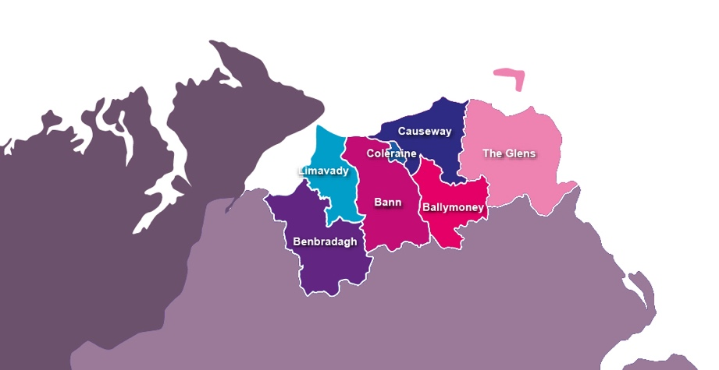

Causeway Coast and Glens Borough elected members

Party Abbreviations: ALL – Alliance Party, DUP – Democratic Unionist Party, IND – Independent, SDLP – Social Democratic & Labor Party, SF – Sinn Féin, TUV – Traditional Unionist Voice, PUP – Progressive Unionist Party, UUP – Ulster Unionist Party, DEA – District Electoral Area

Every effort is made to ensure the information contained within this newsletter is correct at time of print

Ballymoney

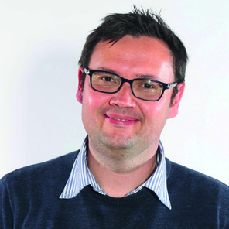
Lee Kane (ALL)
Ballymoney
M: 07342 226 544

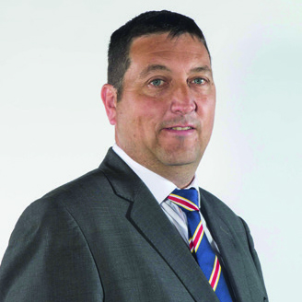
Jonathan McAuley (TUV)
Ballymoney
M: 07864 624 755

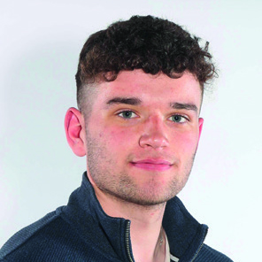
Ciarán McQuillan (SF)
Ballymoney
M: 07512 014 473


Leanne Peacock (SF)
Ballymoney
M: 07511 132 057

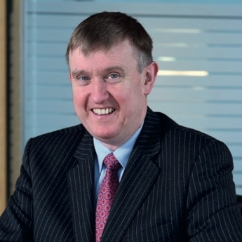
Mervyn Storey (DUP)
Ballymoney
M: 07967 795 684

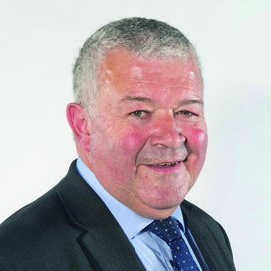
Ivor Wallace (DUP)
Ballymoney
M: 07979 666 343

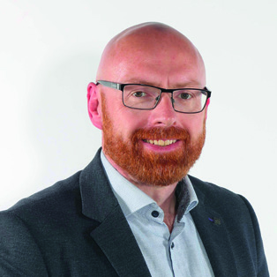
Darryl Wilson (UUP)
Ballymoney
M: 07412 630 814

Benbradagh

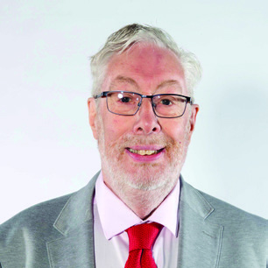
Michael Coyle (SDLP)
Benbradagh
M: 07730 495 797

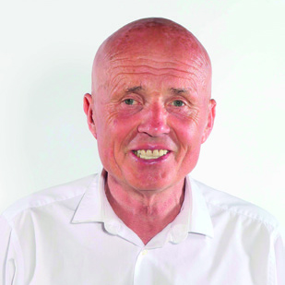
Sean McGlinchey (SF)
Benbradagh
M: 07889 352489

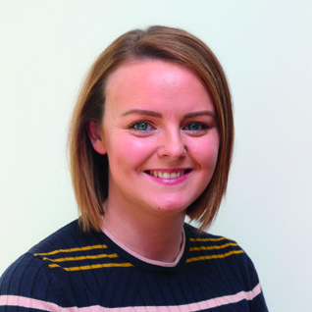
Kathleen McGurk (SF)
Benbradagh
M: 07851 098 477

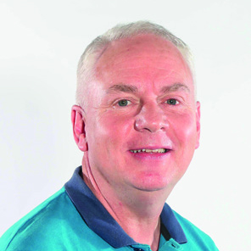
Dermot Nicholl (SF)
Benbradagh
M: 07713 357 592

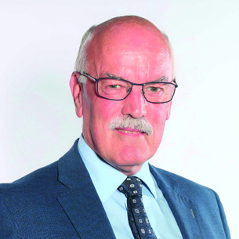
Edgar Scott (DUP)
Benbradagh
M: 07841 355 040

Causeway

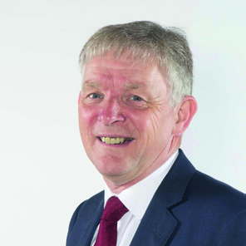
Mark Fielding (DUP)
Causeway
M: 07971 059829

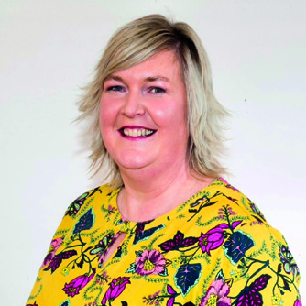
Sandra Hunter (UUP)
Causeway
H: 07850 884 017

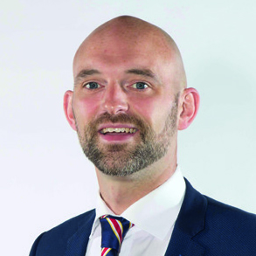
Allister Kyle (TUV)
Casueway
M: 07746 204 135

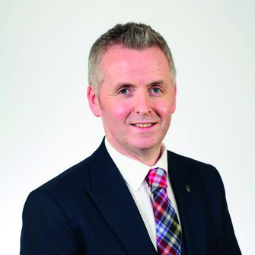
John McAuley (DUP)
Causeway
M: 07736 474 848


Peter McCully (ALL)
Causeway
M: 07708 126 245

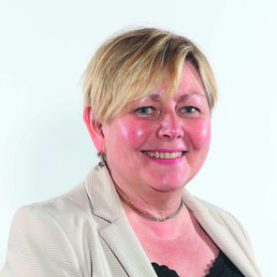
Sharon McKillop (DUP)
Causeway
M: 07793 678991

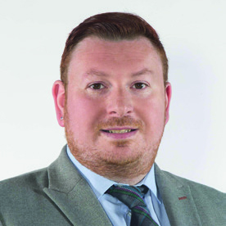
Richard Stewart (ALL)
Causeway
M: 07716 285 822

Coleraine

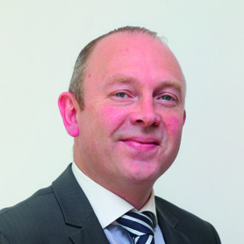
Philip Anderson (DUP)
Coleraine
M: 07772 272 479

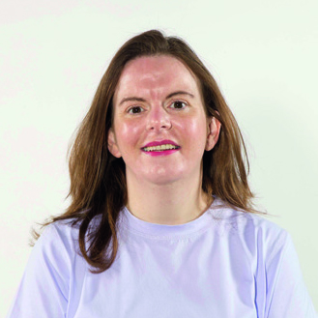
Niamh Archibald (SF)
Coleraine
M: 07725 599 510

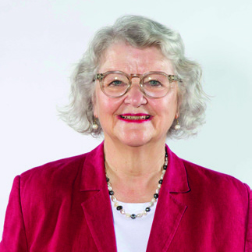
Yvonne Boyle (ALL)
Coleraine
M: 07761 979 251

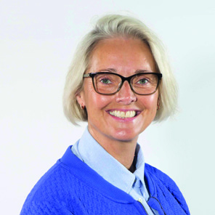
Tanya Stirling (DUP)
Coleraine
M: 02870 356 990

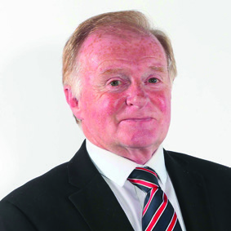
Russell Watton (PUP)
Coleraine
M: 07981 545952

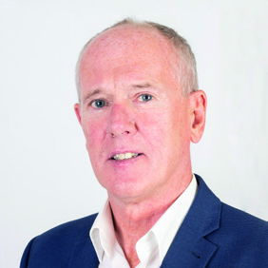
John Wisener (UUP)
Coleraine
M: 07745 655 000

Limavady

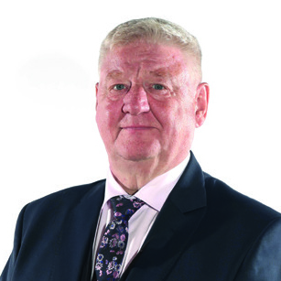
Steven Callaghan QPM (DUP)
Limavady
M: 07824 365 219


Aaron Callan (DUP)
Limavady
M: 07843 879 358

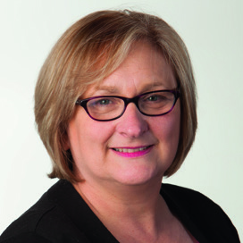
Brenda Chivers (SF)
Limavady
M: 07730 495 794

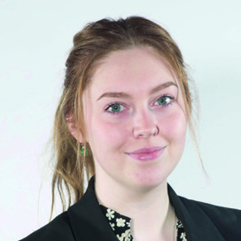
Amy Mairs (ALL)
Limavady
M: 07492 788 484

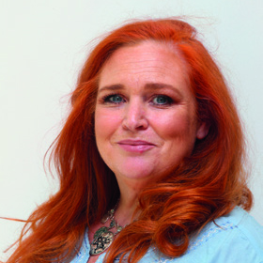
Ashleen Schenning (SDLP)
Limavady
M: 07720 046 169

The Glens

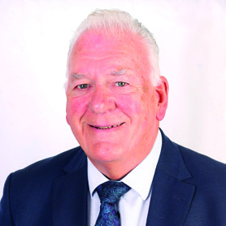
Bill Kennedy (DUP)
The Glens
M: 07734 776 694

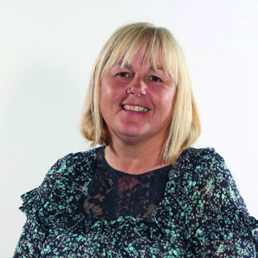
Margaret Anne McKillop (SDLP)
The Glens
M: 07850 883716

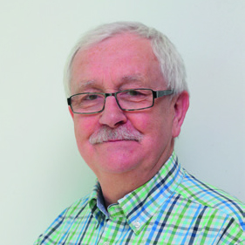
Oliver McMullan (SF)
The Glens
M: 07803 505 081

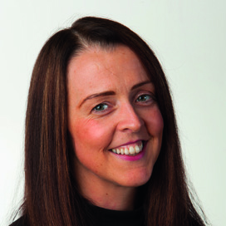
Cara McShane (SF)
The Glens
M: 07752 417316

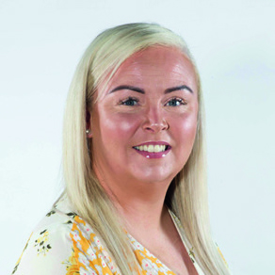
Maighréad Watson (SF)
The Glens
M: 07731 156 451

Bann

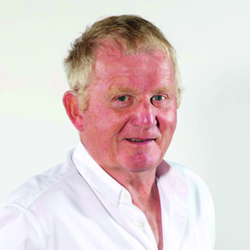
Ciarán Archibald (SF)
Bann
M: 07565 702 743

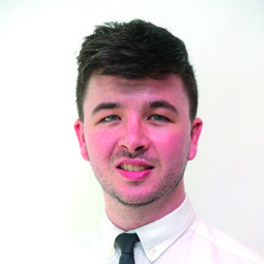
Sean Bateson (SF)
Bann
M: 07417 688 160

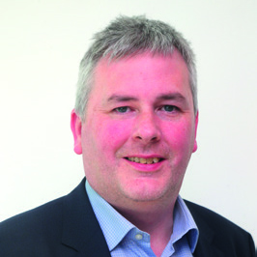
Richard Holmes (UUP)
Bann
M: 07884 303 639

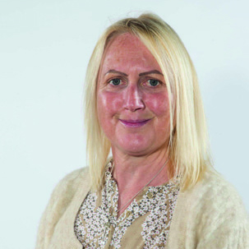
Dawn Huggins (DUP)
Bann
M: 07966 504 064

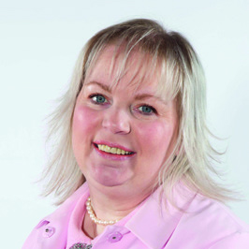
Michelle Knight-McQuillan (DUP)
Bann
M: 07793 544 264

Visit us online:

Website:
Casueway Coast and Glens Website

Facebook:
Causeway Coast and Glens Facebook

Twitter:
Causeway Coast and Glens Twitter

